NB: Yellow = nursery, non-highlighted = HA nurs/rec
Role Play  – Playing alongside others, communicating, sharing ideas, negotiating and co-operating  – Recreating familiar, real-life scenarios; being a family, being mum, dad, siblings, pets  – Acting out common scenarios such as meal times, feeding baby, watching TV, reading, birthdays, coming and going in and out, etc  – Making decisions about the resources they need  – Handling and using resources, managing and organising resources, getting things out and tidying away  – Pretending to be characters, real-world and imaginary; play in character, with different voices and expressions  – Making notes, lists, reading food labels, postcards, recipe books, birthday cards, telling the time  – Talking about what they are doing, describing their actions, what they see happening, sharing their ideas, linked to language for thinking | Observations
Small World  - Make decisions about the resources they need  - Plan and communicate their ideas  - Express their thoughts and ideas to others, adults and children  - Co-operate with peers and share resources  - Create imaginative and real world scenarios  - Create stories around a set of characters  - Create stories with a familiar pattern and sequences  - Retell stories to and/or share story ideas with an audience  - Act out familiar experiences  - Narrate their play  - Design a setting for a story and characters  - Adapt and modify ideas, trial and error  - Reflect on progress and outcome of their ideas  - Draw and/or label designs and/or create maps of their story setting  - Find ways to record ideas and stories  - Experiment with and use a range of vocabulary to describe their designs, ideas and stories  - Use mathematical, descriptive, scientific, geographical language to describe settings and characters | Observations
Sand  – Selecting, holding, filling, emptying, manipulating, marking, flattening using fine motor skills  – Making decisions around the resources they need  – Caring for resources appropriately  – Filling and measuring with increasing accuracy  – Actively sorting, matching, comparing, ordering and positioning  – Patting, shaping, flattening, smoothing, marking and manipulating the sand  – Independently making marks in the sand with hands or tools  – Talking about the texture of sand and the change in texture when water is added  – Talking about what they are doing, describing their actions, what they see happening, sharing their ideas, linked to language for thinking  – Making up stories, acting out events, pretending to be characters, creating imaginative and real-world scenarios linked to communication and language  – Narrating their play linked to language and expressive arts | Observations
Dough  -Selecting, holding, manipulating, marking, cutting, flattening using fine motor skills  – Making decisions around the resources they need  – Caring for resources appropriately  – Cutting, rolling and shaping with increasing accuracy  – Patting, shaping, flattening, smoothing, marking and manipulating the dough  – Independently making marks in the dough with hands or tools  – Talking about the texture and shape of the dough and the changes as it is manipulated  – Talking about what they are doing, describing their actions, what they see happening, sharing their ideas, linked to language for thinking  – Making up stories, acting out events and special occasions, pretending to be characters, creating imaginative and real-world scenarios linked to communication and language  – Talking about number and using language linked to ages and birthdays  – Narrating their play linked to language and expressive arts | Observations
Water  – Selecting, holding, manipulating resources linked to PD  – Pouring, filling and measuring with increasing accuracy and linked to maths, volume and capacity  – Actively counting, sorting, matching, comparing, ordering and positioning linked to maths and numbers  – Stirring, whisking, mixing water observing how it moves, what it can do, feels like linked to UW, Science  – Dropping, sliding, blowing, pushing objects into water, investigating how they move and can be moved linked to UW, Science  – Talking about what they are doing, describing their actions, what they see happening, sharing their ideas, linked to language for thinking  – Making up stories, acting out events, pretending to be characters, creating imaginative and real world scenarios linked to communication and language  – Narrating their play linked to language and expressive arts  – Making decisions around the resources they need linked to PSED  – Caring for resources appropriately linked to PSED | Observations
Mark Making  – Making decisions about the resources they need  – Planning and communicating their ideas  – Expressing their thoughts and ideas to others through mark making  – Co-operating with peers and sharing resources  – Documenting familiar experiences and play narratives  – Creating and documenting stories from their imagination  – Retelling stories to and/or share story ideas with an audience  – Exploring different ways of making marks  – Writing, drawing and creating patterns for a purpose  – Developing ways of recording and documenting their experiences and ideas  – Reflecting on their progress and the outcome of their ideas  – Practising writing and drawing skills; developing a tripod grip and increasing control over mark makers  – Creating books, cards, letters, invitations and notes  – Putting phonics knowledge into practice through writing; blending and segmenting words  – Developing grapheme recognition and capacity to write graphemes and words  – Experimenting with and using a range of vocabulary to describe their designs and ideas  Investigation/nature  --Making decisions about the resources they need  – Exploring resources on their own or with a friend  – Carefully observing, noticing and investigating resources, sharing and talking about what they notice  – Planning what to do next and communicating this  – Expressing their thoughts and ideas to others through talk and mark making  – Co-operating with peers and sharing resources  – Carefully observing, noticing and investigating the world around them  – Asking questions about the things they observe  – Experimenting with and using a range of vocabulary to formulate and describe their ideas  – Reflecting on their progress and the outcome of their ideas  – Formulating hypotheses about what and why things happen and how things work  – Testing ideas and theories  – Developing ways of recording and documenting their experiences and ideas. | Observations
Snack  - Sit down at the table  - Hand gel  - Look at the fruit options  - Choose which fruit to eat (understanding likes and dislikes)  - Peel fruit (understand which fruit needs peeled)  - Large shoulder rotation  - Elbow rotation  - Wrist rotation  - Small and controlled wrist movements  - Whole hand grasp to make sweeping movements  - Move through grasp phases getting used to only moving hand through the wrist (see ABC Getting Ready to Write)  - Pincer  - Cross the midline where needed  - Know if help is needed  - Bite small pieces at a time  - Chew and swallow before taking next bite  - Tidy any rubbish  - Understand hygiene (why hands need to be clean) | Observations
Using Scissors to cut  - Large shoulder rotation  - Elbow rotation  - Wrist rotation  - Small and controlled wrist movements  - Whole hand grasp to make sweeping movements  - Move through grasp phases getting used to only moving hand through the wrist (see ABC Getting Ready to Write)  - Pincer  - Tweezers  - Lifting scissors  - Finger placement  - Open and close scissors  - Simple snips  - Controlled cutting | Observations
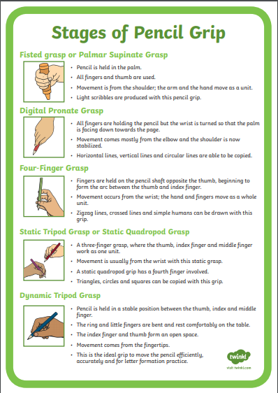  Pencil Control  - Large shoulder rotation  - Elbow rotation  - Wrist rotation  - Small and controlled wrist movements  - Whole hand grasp to make sweeping  movements  - Pincer control (index finger and thumb)  - Palmar supinate grasp  - Digital pronate grasp  - Four finger grasp  - Static tripod grasp  - Dynamic tripod grasp | Observations
Writing  Toddlers (Ages 1–2 years)  - Hold crayon in clenched fist  - Understand that crayons are used for making scribbles  Nursery/early Reception (Ages 3–4 years)  - Draw wavy lines across the page that look like lines of text from a book  - Make distinct marks that look like letters and that are separated from each other  - Write some actual letters, especially the letters in their name  - May write their name  - May try different kinds of writing, like writing a list or a card  - May start to draw pictures and label them using letters or letter-like marks  Reception into Year One (Ages 5 - 6years)  - Hold pencil correctly and form letters accurately  - Know the sounds letters make and spell words based on how they sound  - Spell some common words that aren’t spelled the way they sound  - Use different endings for the same word, like walks, walking, and walked  - Label pictures with a few words and begin to write simple sentences with correct grammar  - By the end of reception/ early year one, write sentences about personal experiences and what they’re learning in school  - May start using different genres of writing like narratives or using writing to express their opinions ‘I like this because…’  ELG 2021  - Write recognisable letters, most of which are correctly formed.  - Spell words by identifying sounds in them and representing the sounds with a letter or letters.  - Write simple phrases and sentences that can be read by others. | 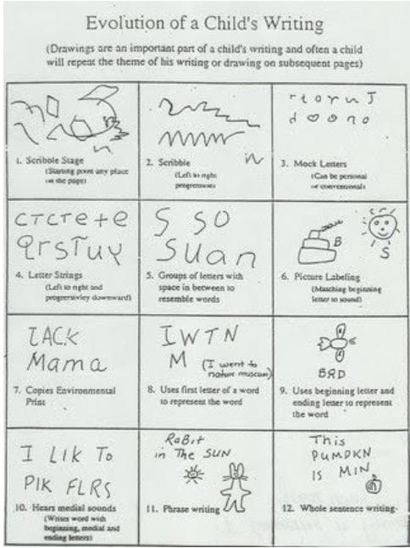  Observations
Drawing  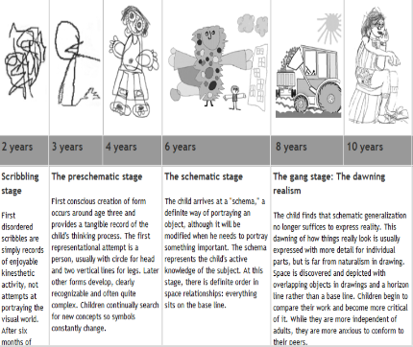  - Up to 2 ½ years  - Random scribbling  - 2 – 3 years  - Controlled scribbling  - 2 ½ - 3 ½ years  - Lines and patterns  - 3 – 5 years  - Pictures of objects/people  - 3 – 5 years  - Letter and words practise | Observations
Reading  Nursery  Enjoys rhyming and rhythmic activities.  Shows awareness of rhyme and alliteration.  Recognises rhythm in spoken words.  Listens to and joins in with stories and poems, one-to-one and also in small groups.  Joins in with repeated refrains and anticipates key events and phrases in rhymes and stories.  Beginning to be aware of the way stories are structured.  Suggests how the story might end.  Listens to stories with increasing attention and recall.  Describes main story settings, events and principal characters.  Shows interest in illustrations and print in books and print in the environment.  Recognises familiar words and signs, such as own name and advertising logos.  Looks at books independently.  Handles books carefully.  Knows information can be relayed in the form of print.  Holds books the correct way up and turns pages.  Knows that print carries meaning and, in English, is read from left to right and top to bottom.  Reception  Continues a rhyming string.  Hears and says the initial sound in words.  Can segment the sounds in simple words and blend them together and knows which letters represent some of them.  Links sounds to letters, naming and sounding the letters of the alphabet.  Begins to read words and simple sentences.  Uses vocabulary and forms of speech that are increasingly influenced by their experiences of books.  Enjoys an increasing range of books.  Knows that information can be retrieved from books and computers.  ELG 2021  Comprehension  - Demonstrate understanding of what has been read to them by retelling stories and narratives using their own words and recently introduced vocabulary.  - Anticipate (where appropriate) key events in stories.  - Use and understand recently introduced vocabulary during discussions about stories, non-fiction, rhymes and poems and during role play.  Word Reading  - Say a sound for each letter in the alphabet and at least 10 digraphs.  - Read words consistent with their phonic knowledge by sound-blending.  - Read aloud simple sentences and books that are consistent with their phonic knowledge, including some common exception words. | Observations
Communication  Nursery  Listens to others one to one or in small groups, when  conversation interests them.  •Listens to stories with increasing attention and recall.  • Joins in with repeated refrains and anticipates key events and  phrases in rhymes and stories.  •Focusing attention – still listen or do, but can shift own  attention.  • Is able to follow directions (if not intently focused on own  choice of activity).  •Understands use of objects (e.g. “What do we use to cut  things?’)  •Shows understanding of prepositions such as ‘under’, ‘on  top’, ‘behind’ by carrying out an action or selecting correct  picture.  •Responds to simple instructions, e.g. to get or put away an  object.  •Beginning to understand ‘why’ and ‘how’ questions.  •Beginning to use more complex sentences to link thoughts  (e.g. using and, because).  •Can retell a simple past event in correct order (e.g. went down  slide, hurt finger).  •Uses talk to connect ideas, explain what is happening and  anticipate what might happen next, recall and relive past  experiences.  •Questions why things happen and gives explanations. Asks  e.g. who, what, when, how.  •Uses a range of tenses (e.g. play, playing, will play, played).  •Uses intonation, rhythm and phrasing to make the meaning  clear to others.  •Uses vocabulary focused on objects and people that are of  particular importance to them.  •Builds up vocabulary that reflects the breadth of their  experiences.  •Uses talk in pretending that objects stand for something else  in play, e,g, ‘This box is my castle.  Reception  •Maintains attention, concentrates and sits quietly during  appropriate activity.  •Two-channelled attention – can listen and do for short span.  Early Learning Goal  Children listen attentively in a range of situations. They  listen to stories, accurately anticipating key events and  respond to what they hear with relevant comments,  questions or actions. They give their attention to what  others say and respond appropriately, while engaged in  another activity.  •Responds to instructions involving a two-part sequence.  Understands humour, e.g. nonsense rhymes, jokes.  •Able to follow a story without pictures or props.  •Listens and responds to ideas expressed by others in  conversation or discussion.  ELG 2021  - Participate in small group, class and one-to-one discussions, offering their own ideas, using recently introduced vocabulary.  - Offer explanations for why things might happen, making use of recently introduced  - vocabulary from stories, non-fiction, rhymes and poems when appropriate.  - Express their ideas and feelings about their experiences using full sentences, including use of past, present and future tenses and making use of conjunctions, with modelling and support from their teacher. | Observations
Block Play/early building
Blocks are carried around, not used for construction
Building begins. Children mostly make rows, either horizontal on the floor or vertical (stacking)
Bridging: two blocks with a space between them, connected by a third block
Enclosures: four blocks placed to enclose a space
When facility with blocks is acquired, patterns and symmetry can be observed
Naming of structures, with names relating to function of building
Buildings often represent actual structures children know from real life or stories. Strong impulse to dramatic play around the structures

Coil
• Large shoulder rotation
• Elbow rotation
• Wrist rotation
• Small and controlled wrist movements
• Whole hand grasp to make sweeping movements
• Move through grasp phases getting used to only moving hand through the wrist (see ABC Getting Ready to Write)
• Pincer

- Coil around an object (e.g. string around a pencil)
- Hold string and coil
- Secure end with pincer grip on non-dominant hand and use dominant hand to coil it around.
- Secure coil

Mould
Large shoulder rotation
• Elbow rotation
• Wrist rotation
• Small and controlled wrist movements
• Whole hand grasp to make sweeping movements
• Move through grasp phases getting used to only moving hand through the wrist (see ABC Getting Ready to Write)
• Pincer
- Pick up chosen material in one hand
- Hold material (e.g. dough) in one hand and use the other hand to pat or squeeze the material.
- With two hands use whole hand grasp to manipulate the material into their chosen shape.
- Squeeze Pat, pinch, roll, prod the material into their chosen shapes.

Print

- Large shoulder rotation
• Elbow rotation
• Wrist rotation
• Small and controlled wrist movements
• Whole hand grasp to make sweeping movements
• Move through grasp phases getting used to only moving hand through the wrist (see ABC Getting Ready to Write)
• Pincer
- To cross the mid line
- Pick up item in one hand and dip said item in the substance of your choice.
- To twisting the item in the substance
- Understanding when there is enough substance e.g. paint on.
- Pick up item in a grasp move it onto paper or material
- Press item onto the material and put pressure onto the material so it will make a mark.
- Understanding that if the item moves the print wont be as accurate.

Colour Mixing
Begin to mix colours together and basic investigation of what is happening
Notice that the colours mix together to create a new colour
Explore and investigate cause and effect and make basic observations
Begin to investigate creating a specific colour
Have an awareness of the primary colours
Know that the primary colours work together to make secondary colours
Retain which colours work together and apply this to create a chosen colour
Explore tone and shade using black and white paint
Understand what effect adding black and white has on different colours

Sticking
Pritt Stick
Large shoulder rotation
• Elbow rotation
• Wrist rotation
• Small and controlled wrist movements
• Whole hand grasp to make sweeping movements
• Move through grasp phases getting used to only moving hand through the wrist (see ABC Getting Ready to Write)
• Pincer
Take lid off the glue stick
- Hold top of pritt stick with one hand and twist the bottom of the pritt stick to raise the glue.
- To understand how much glue they need and not twist it all up.
- Secure paper with one hand and press down with the pritt stick.
- Move the pritt stick up and down to spread the glue.
- To understand when they have enough glue.
PVA Glue
- Large shoulder rotation
• Elbow rotation
• Wrist rotation
• Small and controlled wrist movements
• Whole hand grasp to make sweeping movements
• Move through grasp phases getting used to only moving hand through the wrist (see ABC Getting Ready to Write)
• Pincer
Pick up glue spreader in one hand
Dip the glue spreader into the PVA glue.
Scrape excess glue onto the side of the pot
Move spreader onto their surface
Move the glue spreader up and down to spread the glue
To spread the glue into a larger surface area
To understand how much glue they need for their creation.
To make sure glue is not just spread into one area.
To attach their chosen object onto the glue.
Extend (to link or lengthen)
Large shoulder rotation
• Elbow rotation
• Wrist rotation
• Small and controlled wrist movements
• Whole hand grasp to make sweeping movements
• Move through grasp phases getting used to only moving hand through the wrist (see ABC Getting Ready to Write)
• Pincer
- Understand that extend means to link/lengthen
- Place first item on surface
- Understand that second item needs to link at end point of first item
- Join and continue

Bury
Large shoulder rotation
• Elbow rotation
• Wrist rotation
• Small and controlled wrist movements
• Whole hand grasp to make sweeping movements
• Move through grasp phases getting used to only moving hand through the wrist (see ABC Getting Ready to Write)
• Pincer
- Understand that burying means concealing an item through digging down, placing item and covering
- Dig hole large enough to fit chosen item
- Place item inside hole
- Use surplus ‘dug’ material to cover item

Enclose
Large shoulder rotation
• Elbow rotation
• Wrist rotation
• Small and controlled wrist movements
• Whole hand grasp to make sweeping movements
• Move through grasp phases getting used to only moving hand through the wrist (see ABC Getting Ready to Write)
• Pincer
- To understand that enclose means to put something inside something else.
- Initial size ordering concepts
  - small into large
  - think stacking cups

