
Navigation Primary Art Knowledge Map
EYFS art in continuous provision
Indoor | - Fine motor activities to build finger dexterity  - Creative areas with a wide range of open-ended materials accessible at all times  - Investigation encouraged eg: colour mixing, experimenting with textures  - Art gallery in each classroom where children can take pride in both child-initiated art activities and display taught pieces  - Self-portraits drawn and displayed at baseline, December and July to show drawing progression  - Small parts trolley
Outdoor | - Large blackboards and white boards  - Paint etc used in different media and in varying ways depending on the weather eg: powder paint on rainy days  - Large textiles available for investigation and play  - Small parts trolley
See EYFS Full Skills Curriculum document links
NB: yellow relates to nursery
Page 4 – Dough
Page 6 – Mark Making
Page 9 – Using scissors to cut
Page 10 – Pencil control
Page 12 – Drawing
Page 15 & 16 – Communication
Page 18 – Coil
Page 19 - Mould
Page 20 – Print
Page 21 – Colour mixing
Page 22 – Sticking
Page 23 – Extend

EYFS
Nursery | Physical Development |  | - Use large-muscle movements to wave flags and streamers, paint and make marks.  - Choose the right resources to carry out their own plan.  - Use one-handed tools and equipment, for example, making snips in paper with scissors.  - Use a comfortable grip with good control when holding pens and pencils.
 | Expressive Arts and Design |  | - Explore different materials freely, in order to develop their ideas about how to use them and what to make.  - Develop their own ideas and then decide which materials to use to express them.  - Join different materials and explore different textures.  - Create closed shapes with continuous lines, and begin to use these shapes to represent objects.  - Draw with increasing complexity and detail, such as representing a face with a circle and including details.  - Use drawing to represent ideas like movement or loud noises.  - Show different emotions in their drawings and paintings, like happiness, sadness, fear, etc.  - Explore colour and colour mixing.
Reception | Physical Development |  | - Develop their small motor skills so that they can use a range of tools competently, safely and confidently.  - Use their core muscle strength to achieve a good posture when sitting at a table or sitting on the floor.  - Develop overall body-strength, balance, coordination and agility.
 | Expressive Arts and Design |  | - Explore, use and refine a variety of artistic effects to express their ideas and feelings.  - Return to and build on their previous learning, refining ideas and developing their ability to represent them.  - Create collaboratively, sharing ideas, resources and skills.
ELG | Physical Development | Fine  Motor Skills | - Hold a pencil effectively in preparation for fluent writing – using the tripod grip in almost all cases.  - Use a range of small tools, including scissors, paintbrushes and cutlery.  - Begin to show accuracy and care when drawing.
 | Expressive  Arts and Design | Creating  with Materials | - Safely use and explore a variety of materials, tools and techniques, experimenting with colour, design, texture, form and function.  - Share their creations, explaining the process they have used.

 | Artistic Knowledge | Drawing | Painting | Collage and Textiles | Sculpture
1 | I know how to describe what I can see and like in the works an artist. E.g. Yayoi Kasuma and Andy Warhol.  I know one of Andy Warhol’s artistic styles was to repeat the same picture in different colours.  I know Yayoi Kusama’s art is based on dots.  Vocabulary: artist, art, discuss, like, dislike, colours, shapes,  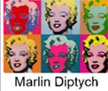 | I know how to draw lines of different shapes and thicknesses.  I know how to draw with crayons and different grades of pencils.  I know how to describe the shapes and patterns I see.  I know how to use a range of media to draw with such as chalk, fingers.  Vocabulary: line, wavy, thick, thin, zigzag, shape, 2D, flat, pattern, spotted, striped | I know how to use thick and thin brushes.  I know how to use ready mixed or powder paints to show my ideas.  I know how to paint pictures of what I see.  I know the name the primary and secondary colours.  Vocabulary: brush, thick, thin, paint, colour, shade, mix, primary colours (red, yellow, blue), secondary colours (green, purple, orange)  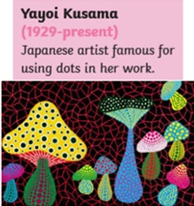 | I know how to make weavings with fabrics or threads.  I know how to explore and experiment with lots of collage materials to make individual and group collages.  I know how to cut and tear paper, textiles and card for my collages.  I know how to use repeated patterns in a collage.  I know how to sort and arrange collage materials for a purpose e.g. to create an ‘Under the Sea’ wall hanging.  Vocabulary: cut, tear, stick, paper, materials, colour, shapes, overlap, on top of, underneath, layers, texture (e.g. rough, smooth, bumpy, soft, hard, prickly, furry, flat, shiny, hairy, spotted, striped)  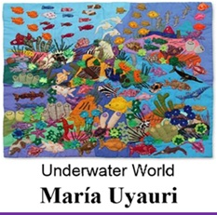 | I know how to make shapes from rolled up paper, straws, paper and card.  I know how to cut, roll and shape a variety of material such as clay, dough, plasticine e.g. to make an animal.  I know how to texture to my models using tools e.g. a knife, clay tools.  I know how to manipulate clay to make a thumb pot.  Vocabulary: Model, build, make, create, join, stick, tools, change, squash, squeeze, cut, crumple, pinch, knead, scrunch, stretch, bend, snap, twist, roll, pull, flatten, junk, 3D
 | Artistic Knowledge | Drawing | Painting | Collage and Textiles | Sculpture
2 | I know how some artists have used colour, pattern and shape e.g. Kandinsky, Mondrian and William Morris.  I know how to create a piece of work in response to another artist’s work e.g. Kandinsky, Andy Goldsworthy.  I know Kandinsky’s art is abstract meaning he uses shapes and lines to represent an image without it being realistic.  I know that Andy Goldsworthy’s art is inspired by nature.  Vocabulary: line, colour pattern, shape, line, discover, express, tell a story, emotions, detail, style, technique. | I know the different techniques I can use with media, such as pencils and oil pastels to create different effects e.g. by smudging some media to create a blurred effect, by layering oil pastels to create mixed colours.  I know how to show patterns and textures in my drawings by adding dots and lines e.g. hatching.  I know how to create different tones – light and dark by applying different pressures to the media when drawing.  I know how to use a view finder to focus on a specific part of an object before drawing it.  Vocabulary: grade of pencil, crayons, pastels, felt tips, charcoal, chalk, view finder, scale, large, small, still life, natural, manmade, tone, texture, patterns, hatched, lines  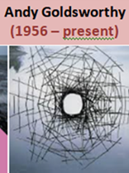 | I know how to mix primary colours to make secondary colours.  I know how to make brown by mixing varying amounts of all the primary colours.  I know that adding white to colours lightens the colour to make tints.  I know that adding black to colours darkens the colour to make shades.  Vocabulary: brushes (hard, soft, bristles) realistic, abstract, represent, mix, tint, shade, light, dark, bright, muted  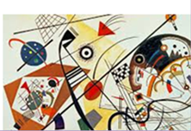 | I know I can print in different ways e.g. by pressing, rolling, rubbing and stamping.  I know where print-making and patterns are evident in art and everyday objects (wallpapers, fabrics etc) and have used it as an inspiration for my own work e.g. African art based on animals.  I know how to make a collagraph printing plate (with foam and cardboard) and how to use it to create an animal print.  Vocabulary: Print, image, apply, shape, surface, pattern, repeated pattern, texture, texture rubbings, transfer, printing plate, roll, rub, press, stamp, purpose, spotted, striped, environment, wallpaper, wrapping paper, animal print  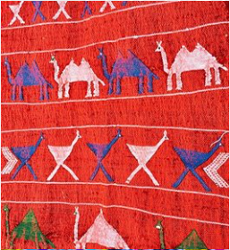 | I know how to use a paint program to draw pictures in the style of various artists and art movements e.g. Mondrian, Picasso, impressionism, Pointillism.  I know how to edit my work using cut, copy, paste and erase.  I know how to manipulate shapes on screen by changing position, size and colour.  Vocabulary: Mondrian, Picasso, impressionism, abstract, style, cut, copy, paste, shape, size, colour, effect  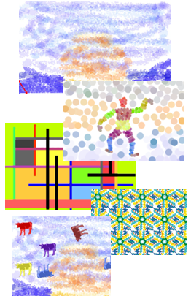
 | Artistic Knowledge | Drawing | Painting | Collage and Textiles | Sculpture
3 | I know how to compare the work of different artists; including those from other cultures and different time periods e.g. compare the portraits by Caterina de Vigri, Jan Vermeer, Eduard Manet, Pablo Picasso, Frieda Kahlo and William Kentridge.  I know how to look at an artist’s work and make inferences about what the artist might be feeling or trying to express.  Vocabulary: individual style, techniques, materials, imagination, observation, memory, arrange, represent, abstract, real life, audience  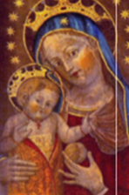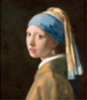  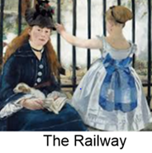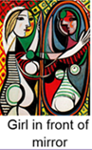  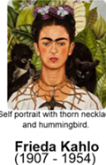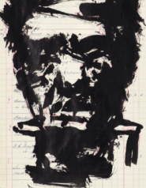 | I know how to use a number of sketches to base my work on.  I know how to use a viewfinder to help me in my sketching.  I know how to annotate my sketches in my art sketchbook to explain my ideas, e.g. explaining which pencil type was used to produce a specific effect.  I know how to sketch lightly so I do not need to use a rubber.  I know which grade of pencil to use and how much pressure to apply to best show tones.  I can include facial expressions in my drawing.  Vocabulary: observational, smudge, mix, layer, dotting, hatching, cross hatching, pressure, light, shadow, emotions such as angry, surprised, excited | I know how to mix colours using tints and shades.  I know how to use watercolour paint to produce washes for backgrounds and then add detail.  I know how to create mood and feelings by experimenting with colour.  Vocabulary: tint, shade, complementary, contrasting, pale, pastel, bold, earthy, vibrant, subtle  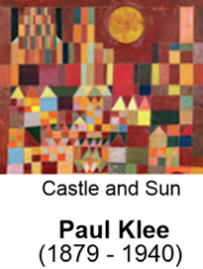 | I know how to cut with precision.  I know how to produce quilling art using techniques such as coiling and overlapping  I know the striking effect working in a limited colour palette can have, through experimentation.  I know how an artist uses quilling in her work e.g. Yulia Brodskaya  I know how to colour fabric and have used this to add pattern.  Vocabulary: quilling, coiling, overlapping, pinching, combining, colour palette  dye, fabric, effect, stain  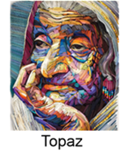 | I know how to use guides to roll clay to a given uniform thickness.  I know how to use ‘slip’ and cross hatching in order to join clay elements to a slab to create form.  I know how to add colour and texture to clay using paint and tools.  Vocabulary: clay, mould, pinch, slab, roll, join, slip, score, engrave, carve, texture, malleable  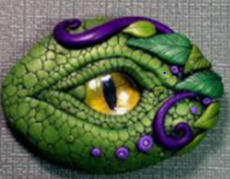
 | Artistic Knowledge | Drawing | Painting | Collage and Textiles | Digital Art
4 | I know how to experiment with different styles which artists have used and adapt them when producing my own work e.g. L. S. Lowry, Van Gogh.  I know L. S Lowry was a local artist whose artwork generally reflects the urban landscape and people’s daily lives of Industrial Britain.  I know that Vincent Van Gogh used colour to reflect mood created by weather in some of his paintings.  I discuss my own and artist’s work in terms of content, mood and style.  Vocabulary: line, shape, tone, texture, content, foreground, mid-ground, background, application, mood, individual style | I know how to investigate the different effects I can achieve with a variety of drawing media such as pencil, charcoal, oil pastels, pen.  I know how to use a number of sketches to base my work on.  I know how to use a viewfinder to help me in my sketching.  I know how to annotate my sketches in my art sketchbook to explain my ideas. E.g. to show what media I have used, what techniques I have used, the mood I am trying to create.  I know how to organise line, tone, shape and colour to show figures in movement.  Vocabulary: urban, perspective, blend, smudge, clean line, fine, sketch, solid, light, shadow, 3D effects, gradient, proportion, observational drawing  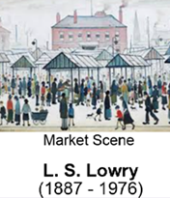 | I know how to mix colours using tints and shades to suggest a variety of moods.  I know how to paint adding different layers and detail to my work to produce a more 3D effect, e.g. produce washes for the background and then add detail using different brush strokes and techniques such as stippling, swirling, dabbing, spraying.  I experiment in creating mood and feelings with colour to produce two contrasting paintings in the style of an artist e.g. Vincent Van Gogh  Vocabulary: landscape, shadow, tint, shade, texture, contrasting, vivid, muted, formal, patterned, abstract, detailed, figurative, three-dimensional, composition, dabbing, stippling, paint wash, swirling  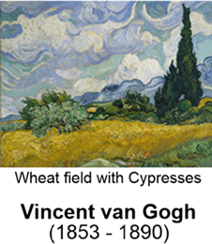 | I know how to make my own relief print block by etching into polystyrene.  I know how to make a one coloured print.  I know how to print onto different materials and can describe the effect.  I know how to build up layers of colours to make prints of 2 or more colours.  I know how to use my printing block to create repeated patterns  I know how printing is used in the everyday life of designers or artist e.g. I know how Rebecca Vincent uses layering, marking, texture and blanking to produce her prints.  Vocabulary: relief print, inking, etch, carve, monochrome, overlay, off set, blank off, layering  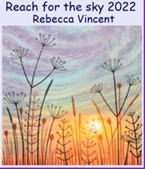 | I know how to use a digital camera to take images of the local area.  I know how to experiment with points of view e.g. close up, distance, and different angles to create effects. E.g. distorted, overpowering, blurry  I can create a montage of my photos e.g. to reflect a dream-like mood.  I can write about my ideas and add sketches and annotations to my montage explaining my use of techniques and the mood I want to create.  Vocabulary: digital, viewpoint, focus, blurred, close up, distance, distorted, manipulate, distorted, abstract  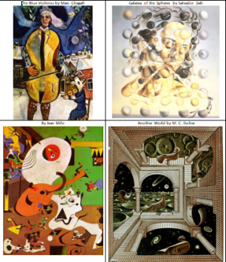
 | Artistic Knowledge | Drawing | Painting | Collage and Textiles | Digital Art
5 | I know different styles which artists, such as Georgia O’Keeffe and Clarice Cliff, have used and can experiment with these. For example, they explore painting close-ups of flowers inspired by O’Keeffe, they make clay pots inspired by Cliff.  I know the work of artists such as Georgia O’Keeffe, Arthur Rackham, Clarice Cliff, from books, internet, galleries etc.  I know the similarities and differences in style used by various sculptors e.g. Clarice Cliff, Josiah Wedgewood, Bernard Leach and Shoji Hamada.  Vocabulary: line, shape. tone, shade, space, form, design, represent, discuss, feel, critic, inspiration, work of artists, approaches, aspects, research, | I know the most suitable drawing materials for the type of drawing I want to produce. E.g. they experiment with different media to discover the effects that can be created with each.  I know how to use shading to add interesting effects to my drawings, using different grades of pencil or varying pressures when working with charcoal.  I know how to make notes in my sketchbook of how artists have produced pattern, colour, texture, tone, shape, space, form and line.  I know how to annotate my work to explain the ideas behind my images in my art sketchbook.  Vocabulary: – observation, pattern, colour, texture, shape, space, form and line, tone, highlight, shadow, mid-tone, varied, visual qualities, tactile qualities, jagged, pitted, matt, line, parallel, swift, undulating, angular. | I know how to create colours by mixing to represent images.  I have observed in the natural and man-made world.  I know how different colours create different moods and experiment with this.  Vocabulary: tertiary, blend, scale, colour palette, colour wheel, translucent, opaque, neutral, sombre, pastel, combine, create, tones, tints, shades, graduated, highlight, shadow, harmonious, contrasting, monochromatic  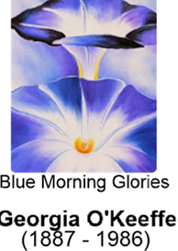 | I know how to create a piece of art including the integration of digital images I have collected/taken.  I know what materials to use and annotate my work to justify why I have chosen to use them.  I know what is meant by pattern, tone and shape and can combine these.  Vocabulary: create, textures, visual qualities, tactile qualities, real-life, abstract, proportion, represent, share, review, reflect, evaluate, purpose, justify  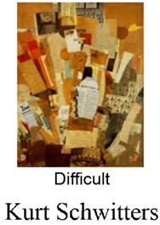 | I know how to use ‘slip’ and cross hatching in order to join clay coils.  I know how to create a coil pot manipulating the clay to form a smooth finish.  I know how to vary the diameter of the pot in order to create an interesting form.  I know how to add pattern and texture to clay using paint and clay tools.  Vocabulary: form, space, coil, slip, manipulate, malleable, , Jasperware, unglazed, Art deco,  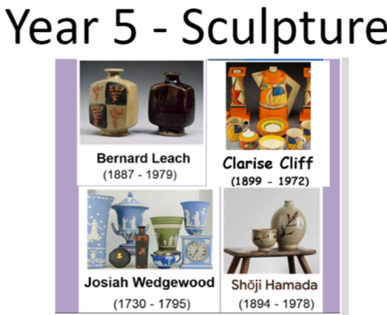
 | Artistic Knowledge | Drawing | Painting | Collage and Textiles | Digital Art
6 | I know how to make notes in my sketchbook about how artists have used different media such as paint, pencil and printing techniques to produce pattern, colour, texture, tone, shape, space, form and line e.g. Hockney (paint), Islamic art (printing).  I know how to explain what my work is influenced by and how I have used or adapted an artist’s style and techniques e.g. Andy Warhol and David Hockney.  Vocabulary: content, process, style, technique, line, shape, form, pattern, colour, texture, tone, space, form, quality, value | I know how to use different grades of pencil at different angles to show different tones.  I know how to use various techniques with a variety of drawing media to show texture and the direction of light and shadow in my drawings, e.g. blending, shading, hatching, cross hatching, stippling, doodling.  I know how to mix media effectively in my work. For example, I draw a jungle animal using charcoal and oil pastels on different textured paper to reflect the colours and textures of the rainforest.  Vocabulary: shading, hatching, stippling, doodling, blending, perspective, composition, focal point, horizon, scale, foreground, middle ground, background, viewpoint | I know how to use water colours to produce backgrounds, shapes, textures, patterns and lines.  I know how to use oil paints to produce backgrounds, shapes, textures, patterns and lines.  I know how to combine water colours and oils to produce a piece of art in the style of an artist.  Vocabulary: traditional, representational, imaginary, modern, abstract, impressionist, stippled, splattered, dabbed, scraped, dotted, stroked, textured, flat, contemporary, layered, opaque, translucent, intense  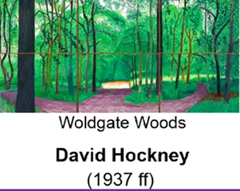 | I know how to make my own relief print block by etching into polystyrene.  I know how to use a different template in order to add a second colour.  I know how to design a printing tile that creates a seamless pattern when repeat printed. For example, I create my Islamic inspired template by cutting and rejoining paper.  I know how to explore printing from other cultures and time periods e.g. Islamic art, woodcut printing (Albrecht Durer), etching (Hockney) sublimation (Dawn Dupree).  Vocabulary: print, relief, etch, engrave, woodcut, sublimation, seamless pattern, Islamic | I know how to use image editing tools such as layering, colour and shape manipulation in Canva to create digital art.  I know how to use layout techniques to represent abstract ideas such as time.  I know that Artificial intelligence in image creation can be used as a tool to support my work.  Vocabulary:

